1 Instructions 1

2 Settings 1

The extract record function can be used to export all fields for a record as well as detail of all related records

# Instructions

* Click the CRM Record Report option from the main menu
* Enter the save to folder, document format and record type
* Search and select a record of the selected type by entering its name (or any number of the starting characters), searching then selecting it from the search match dropdown

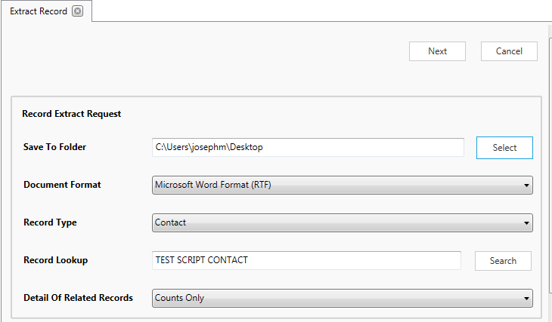

* Click next
* Wait for the system to search and generate the document

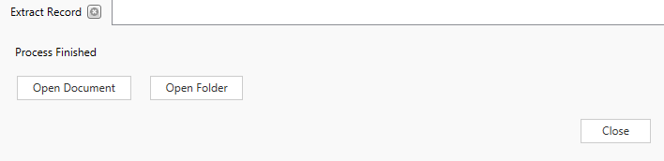

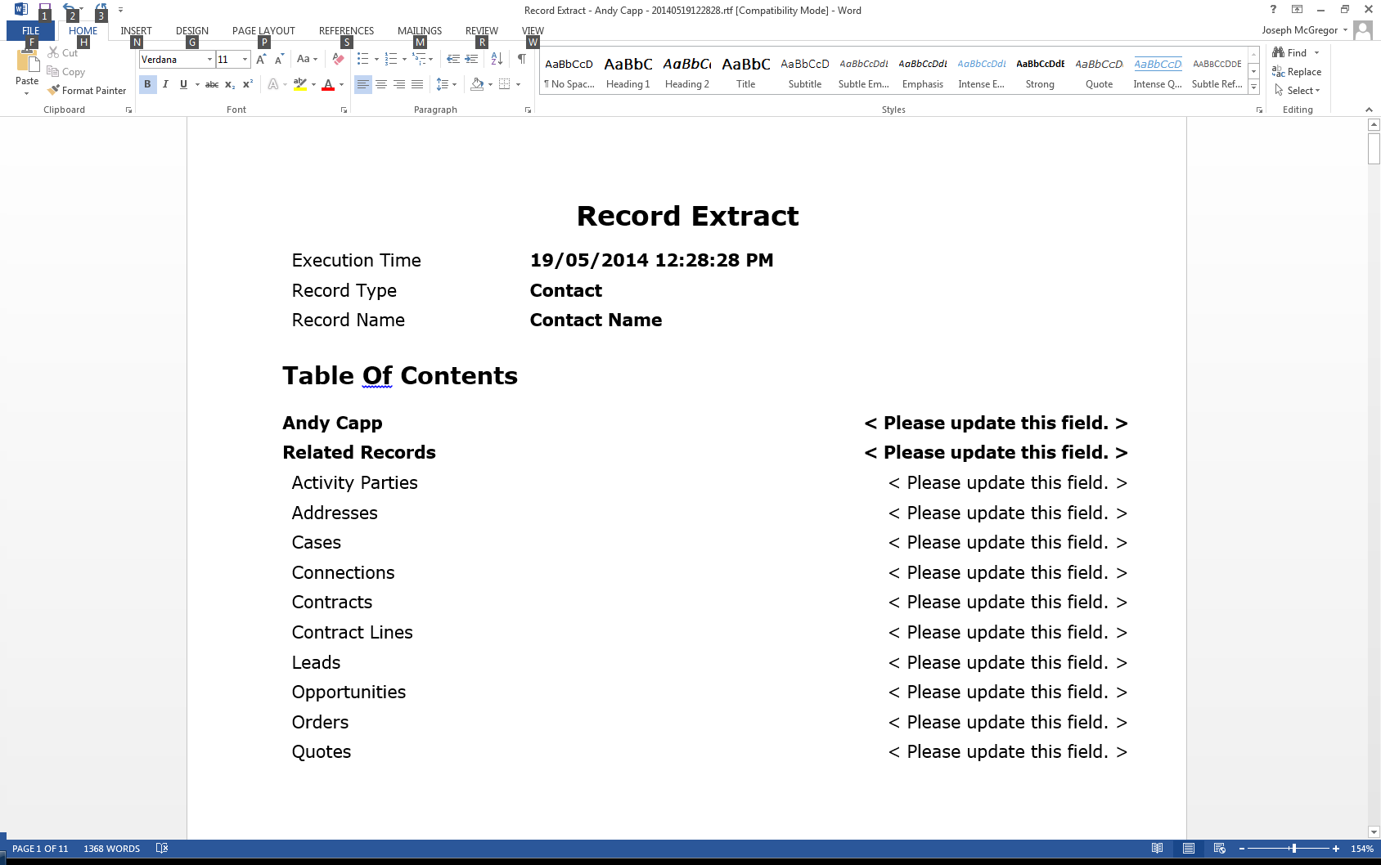

# Settings

There are several settings for the record extract which can be configured by selecting “Record Report Settings” from the settings dropdown

These give the ability to

1. Include or exclude several system fields from the export
2. Limit the types of records which can be selected for export
3. Exclude specific record types from the record types which are output as linked record
4. Specify to only display the name for linked records of a particular type rather than detailing all the fields in the record

